|  |  |  |
| --- | --- | --- |
| **Practical no 2**  **AIM:** Install Selenium server and demonstrate it using a script in Java.  **Theory Selenium Java**  Selenium is an umbrella project for a range of tools and libraries that enable and support the automation of web browsers. It provides extensions to emulate user interaction with browsers, a distribution server for scaling browser allocation, and the infrastructure for implementations of the W3C Web-Driver specification that lets you write interchangeable code for all major web browsers.  **ChromeWebDriver**  WebDriver is an open source tool for automated testing of webapps across many browsers.It provides capabilities for navigating to web pages, user input, JavaScript execution,and more. ChromeDriver is a standalone server that implements the W3C WebDriver standard. ChromeDriver is available for Chrome on Android and Chrome on Desktop (Mac, Linux, Windows and ChromeOS).  **Eclipse IDE**  Eclipse IDE is a famous IDE for java development , Eclipse IDE is open source and has been long in development since 2001. It is licensed under ”Eclipse Public License”.  Eclipse has a lot of extensions and now has many IDEs for different Programming languages as well. | | |
| **Software Testing & Quality Assurance** | 1 |  |
|  | | |

|  |  |  |
| --- | --- | --- |
| **Installation of Selenium server in Eclipse IDE**  Step-1 :- Install JDK,Eclipse IDE for ”java developers”.  Step-2 :- Download ”Chromedriver”,”selenium-java-3.13.0.zip” and ”selenium-server- standalone-3.141.59.jar”.  Step-3 :- Launch the Eclipse IDE.  Step-4 :- Create a new java project give a suitable name and save it.  Step-5 :- Eclipse IDE will open the project. Now add a new java class and give it a name.  Step-6 :- To include the libraries and ”jar” files, Unzip the zipped archives,next ”rightclick on the project icon → BuildP ath → Conf igureBuildP ath..”  Step-7 :- Here we will choose ”Add External JARs...” button and navigate to the ”.jar”  file we downloaded/extracted and select them to include in our project. Software Testing & Quality Assurance  Step-8 :- Save the configuration. You have successfully installed selenium for java. Step-9 :- For linking the chrome driver you need to include it in the code by adding a line  System.setProperty("webdriver.chrome.driver","chromedriver path");  **Testing a Website using selenium(java) in eclipsed IDE**  Step-1 :- Import all the important classes we need from the jar packages we included earlier.  import org.openqa.selenium.By;  import org.openqa.selenium.chrome.ChromeDriver; import org.openqa.selenium.WebDriver;  Step-2 :- Next we will set the path property for chromedriver.  Step-3 :- Next Create a WebDriver object for accessing web contents. Step-4 :- Use ”WebDriver.get()” method to get the base URL . | | |
| **Software Testing & Quality Assurance** | 2 |  |
|  | | |

|  |  |  |
| --- | --- | --- |
| Step-5 :- we can manipulate the browser DOM elements using ”WebDriver.manage() method”.  Step-6 :- Next we have a lot of methods to fetch data from the webpage and we can also manipulate them for the ”By” class.  Step-7 :- Once you are done with the testing close the window using ’WebDriver.close()” method.  Step-8 :- The base URL can be any site hosted either on localserver or on the world wide web.  **Code**  **2A. Test on an External website** | | |
| **Software Testing & Quality Assurance** | 3 |  |
|  | | |

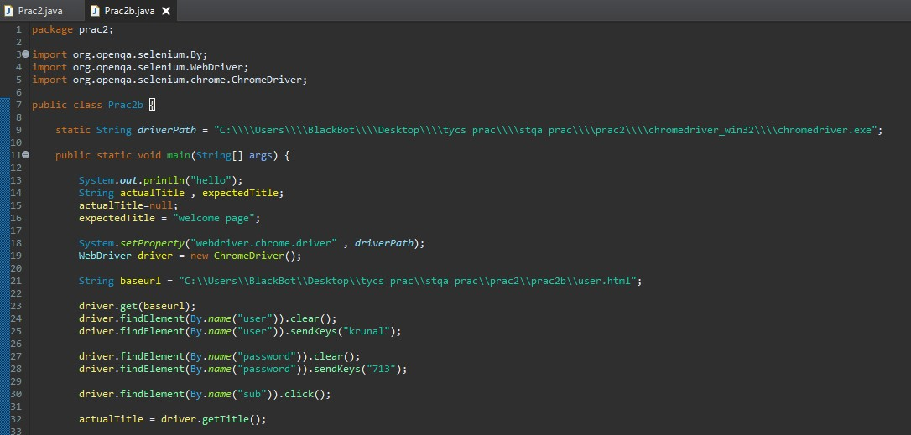

# 2B. Test on an Local Webpage

**Software Testing & Quality Assurance** 4

|  |  |  |
| --- | --- | --- |
| **User.html**  <!DOCTYPE html>  <html>  <body>  <h2>prac 2 </h2>  <form action="welcome.html">  <label for="fname">First name:</label><br>  <input type="text" id="fname" name="user"><br>  <label for="lname">Last name:</label><br>  <input type="password" id="lname" name="password"><br><br>  <input type="submit" value="Submit" name="sub" >  </form>  </body>  </html> | | |
| **Software Testing & Quality Assurance** | 5 |  |
|  | | |

|  |  |
| --- | --- |
| **T.Y. B.Sc. C.S. Sem-V** | Roll No: **713** |
| Date:25/08/2020 |

|  |  |
| --- | --- |
| **T.Y. B.Sc. C.S. Sem-V** | Roll No: **713** |
| Date:25/08/2020 |

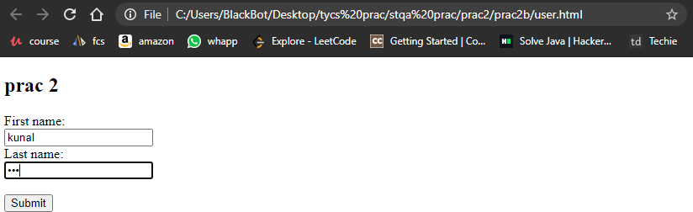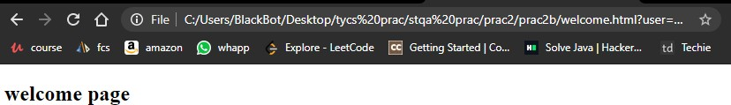

**Welcome.html**

<!DOCTYPE html>

<html>

<head>

<title> welcome page </title>

</head>

<body>

<h2>welcome page</h2>

</body>

</html>

# Software Testing & Quality Assurance 6